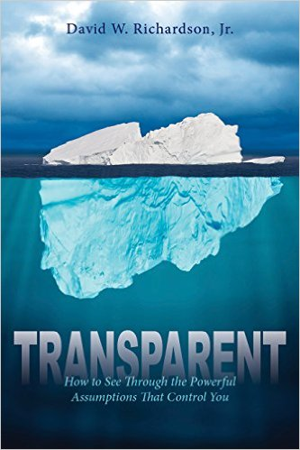

**Interview Questions**

***Transparent: How to See Through the Powerful Assumptions That Control You***

**By Dave Richardson**

**Host: Here’s a staggering statistic: 75 percent of young people raised in church will give up their beliefs and leave their faith, many of them while in college. Yet at the same time, our guest today also reminds us that everyone believes something, even atheists. They *believe* there is no God.**

**Author Dave Richardson is someone whose ministry is defending the faith. He’s spent a number of years learning how people come to faith, and why some abandon it. Dave says it like this: we all make assumptions in life, and they control us, even though most of us have never even stopped to notice these assumptions, let alone understand their power over us.**

**Intriguing, isn’t it? Dave is the author of a new book, *Transparent: How to See Through the Powerful Assumptions That Control You,* and we are delighted to have Dave with us today.**

**He wants to help people learn to see through the assumptions being made in the things they encounter daily in what they read, watch and hear. And he’s here to tell us how to do it.**

**By the way, if you think this sounds hard to figure out – don’t worry, there’s even an app! We will hear more about that as we explore Dave’s concepts for helping people understand God’s truth, based in learning about who God is and how to know him. Welcome, Dave.**

Q. Dave, let’s dive in here. Is this really true – 75% of young people will leave their faith? Where did that statistic come from and why is this happening?

Q. Your ideas can help change that. You want to help people come to faith, or strengthen their faith, by thinking things through, using the brains God gave us. Start us at the beginning. What is this about making assumptions?

Q. You state that these assumptions we make are all inherently religious, even those made by atheists. Is it fair to refer to the “faith of atheists”?

Q. You have developed something you call the Critical Assumptions Test. What is that and how do we use it? What does this test show?

Q. So this is where the app comes in. Tell us about this app.

Q. How did you come to develop this? Tell us a bit more about your background and how you came to develop the Critical Assumptions Test. We know your background includes a number of years working with Cru, formerly Campus Crusade for Christ, but working on college campuses with the professors, not the students.

Q. You’ve written this book, but now what? What are you going to do with this book and your groundbreaking work with assumptions and the Critical Assumptions Test?

Q Thanks for being with us. Last but not least, how can we learn more and where can we get a copy of the book? Are you available for speaking engagements?

***Transparent: How to See Through the Powerful Assumptions That Control You* released in 2016 from Clovercroft Publishing. It is available from Amazon and other online retailers, selected book stores, and from** **http://** [**www.TheTransparentBook.com**](http://www.thetransparentbook.com/)**.**

**For a review copy or to interview Dave Richardson, contact Joni Sullivan Baker, Buoyancy PR, at 513/319-3231 or** [**jbaker@buoyancypr.com**](mailto:jbaker@buoyancypr.com)**.**