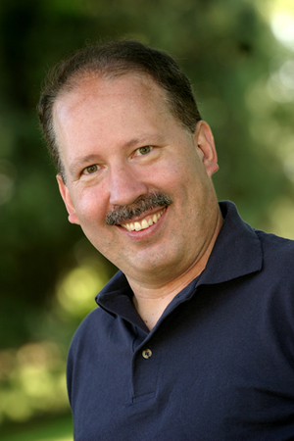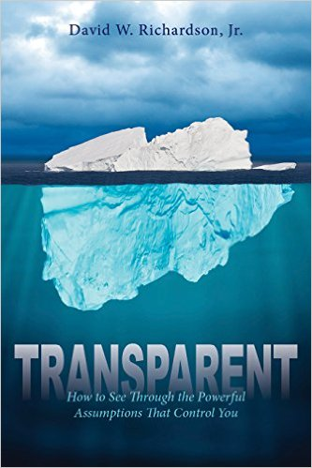

**Author Bio: Dave Richardson**

***Transparent: How to See Through the Powerful Assumptions That Control You***

David Richardson is the founder of the Assumptions Institute and its Chief Executive Officer. Prior to founding the Assumptions Institute, Richardson served for 30 years on the staff of Cru, formerly known as Campus Crusade for Christ, devoting most of his ministry to university professors. The Atlanta-area resident founded the Christian faculty ministry in Atlanta beginning at Georgia Tech in 1996.

He holds a B.A. degree in Interdisciplinary Studies from the University of Portland, and an M.A. degree in Theological Studies from the International School of Theology. Richardson also holds an MTh. degree in Applied Theology from the University of Oxford. His dissertation, “Accepting Christian Faith in the Academy,” was an important exploratory study of the religious attitudes and beliefs of university professors and how to reach them for Christ. He understands education and educators very well.

Richardson is the innovator who discovered the power of assumptions. His research about assumptions enabled him to create the Assumptions Sorter™ and the Critical Assumptions Test. His research, writing, teaching, and speaking is at the heart of the work of the Assumptions Institute.

Richardson’s first book, *Transparent: How to See Through the Powerful Assumptions That Control You* released in 2016 from Clovercroft Publishing. It is available from Amazon and other online retailers, selected book stores, and from http:// [www.TheTransparentBook.com](http://www.thetransparentbook.com/).

**For a review copy or to interview Dave Richardson, contact Joni Sullivan Baker, Buoyancy PR, at 513/319-3231 or** [**jbaker@buoyancypr.com**](mailto:jbaker@buoyancypr.com)**.**